

Workplan for the National Water Census Upper Rio Grande Basin Focus Area Study
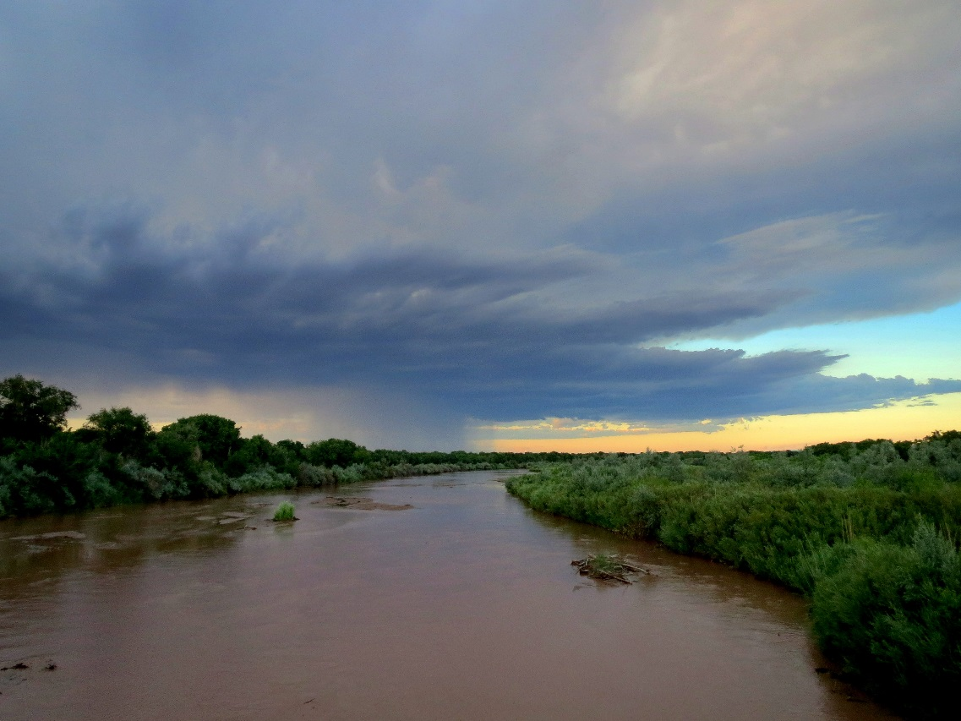

Prepared by personnel from the Colorado, New Mexico, Utah, and Texas Water Science Centers

January 5, 2017 (revised)
Contents
Introduction 1
Background 2
Objectives 5
Scope of Work 6
Methods 8
Water Use (Study Component Lead: Tammy Ivahnenko, Colorado Water Science Center) 9
Sources, Locations, and Use of Withdrawals 10
Domestic Water Use 12
Evapotranspiration and Consumptive Use (Study Component Lead: Gabriel Senay, Earth Resources Observation and Science (EROS) Center) 16
Groundwater (Study Component Lead: Natalie Houston, Texas Water Science Center) 17
Hydrogeologic Framework 18
Water Levels 20
Changes in Groundwater Storage 22
Surface Water 23
Snow Processes (Study Component Lead: Graham Sexstone, Colorado Water Science Center) 26
Streamflow Processes (Study Component Lead: Matt Miller, Utah Water Science Center) 32
Watershed Modeling (Study Component Lead: Kyle Douglas-Mankin, New Mexico Water Science Center) 40
Data and Study Results Visualization (Study Component Lead: Daniel Pearson, Texas Water Science Center) 41
Data Management and Planning (Study Component Lead: Diana Pedraza, Texas Water Science Center) 42
Products and Deliverables 43
Timelines 44
Budget 46
References 48
Figures
Figure 1. Location of the Upper Rio Grande Basin Focus Area Study, Colorado, New Mexico, and Texas. 3
Figure 2. Generalized map of the Rio Grande rift (after Chapin, 1971; from Chapin and Seager, 1975). 18
Figure 3. Site map of existing SNOTEL sites in Region 13. Image from NRCS website (http://www.wcc.nrcs.usda.gov/webmap/index.html, accessed May 11, 2015.) 24
Figure 4. Map of existing and proposed instrumentation within the Rio Grande Headwaters HUC-8 subbasin. 25
Figure 5. Locations of U.S. Geological Survey streamflow gaging stations in the Upper Rio Grande Focus Area Study, Colorado, New Mexico, and Texas. 32
Figure 6. Schematic of data management architecture (modified from Blodgett, 2015). 37

Workplan for the Upper Rio Grande Basin Focus Area Study

Introduction
Increasing demand for the limited water resources of the United States continues to put pressure on resource management agencies to balance the competing needs of ecosystem health with municipal, agricultural, and other uses. The U.S. Geological Survey (USGS) National Water Census is a research program focused on water availability and use, called for in the SECURE Water Act and implemented through the Department of the Interior WaterSMART initiative. The overarching purpose of WaterSMART is to develop data and tools needed by resource managers to meet challenges imposed by increasingly limited water availability due to aging infrastructure, population growth, groundwater depletion, impaired water quality, water needs for human and environmental uses, and climate variability and change. The aim is also to advance the science needed by stakeholders to assess ecological outcomes of management actions that change streamflow regimes as well as to forecast ecological conditions under future scenarios of water availability and management. The objective of the USGS under WaterSMART is to focus on the technical aspects of providing information and tools to stakeholders so that they can make informed decisions on water availability.
In 2014, the Upper Rio Grande Basin (URGB) of Colorado, New Mexico, Texas, and northern Mexico was chosen as a focus area study (FAS) for the USGS National Water Census. The conjunctive use of water in the URGB takes place under a myriad of legal constraints including the Rio Grande Compact (Compact) agreement between the States, an international treaty with Mexico, and several federal water projects. The conveyance and use of surface water in the URGB is achieved through an engineered system of reservoirs, diversions, and irrigation canals, to deliver water to agricultural, residential, and industrial users. Groundwater is used for municipal, industrial, and supplemental agricultural supply and to meet Compact deliveries. As populations increase and agricultural cropping patterns change, demands for water are increasing, as the region is experiencing a decrease in supply due to drought and climate change. Additionally, the quality of available water is a primary factor that can limit its use and availability. The growing gap between supply and demand has resulted in continued conflict over water in the region and ongoing litigation between users and Federal, Tribal, state, and local agencies.

Background
The Rio Grande flows approximately 670 miles from the headwaters in Colorado to Ft. Quitman, Texas, draining the 32,000 square mile URGB watershed (fig. 1). The URGB, primarily located in the Southern Rocky Mountains and Basin and Range physiographic provinces, is an arid to semi-arid region where disputes over water shortages have existed for over 100 years. There are several closed basins on either side of the main drainage, which were not included in the URGB study area. Basin topography varies from the forested mountains and river gorges of the headwaters to the riparian forests (bosque) of the broad valleys and high desert of central New Mexico, to deserts along the boundary between Texas and Mexico (Llewellyn and Vaddey, 2013).
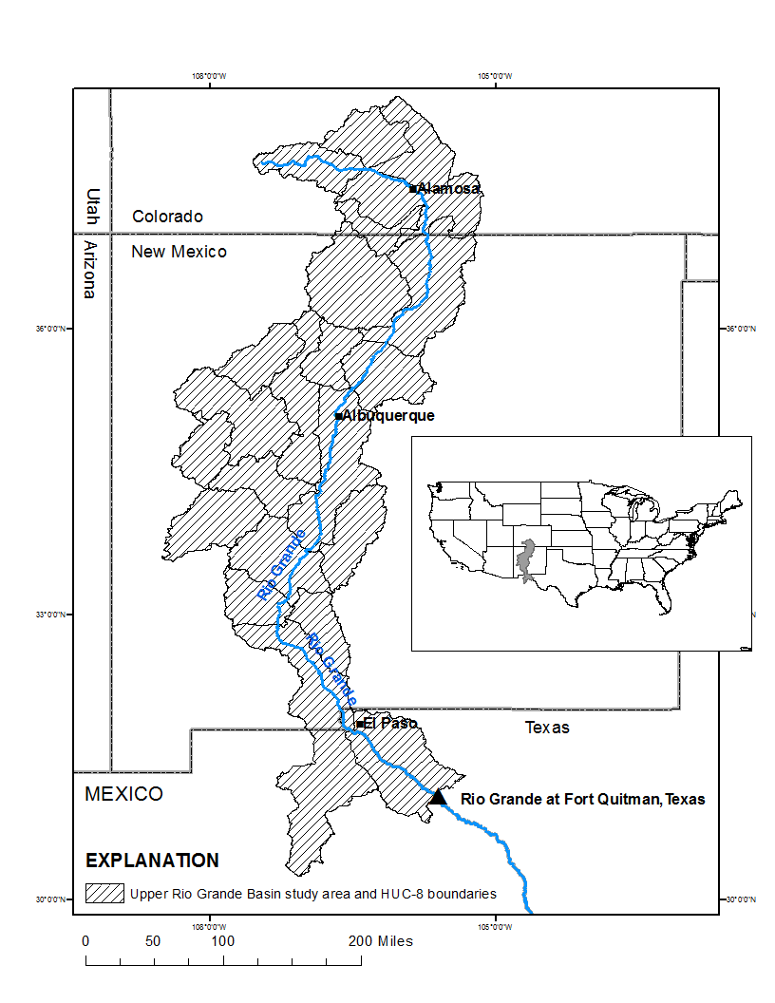
- Location of the Upper Rio Grande Basin Focus Area Study, Colorado, New Mexico, and Texas.
The Rio Grande serves as the primary source of irrigation water for agriculture throughout the basin, as well as for municipal use by the major municipalities along the river corridor (including the cities of Albuquerque and Las Cruces, New Mexico; El Paso, Texas; and Ciudad Juarez, Chihuahua, Mexico), and environmental and recreational uses in Colorado, New Mexico, and Texas, as well as in Mexico (Llewellyn and Vaddey, 2013). Water resources are facing new stresses and demands, and resource managers must understand the role of current and future resource management and development on water availability and sustainability.
Groundwater resources are a critical component to water availability in the URGB. Water users in many areas of the URGB rely on groundwater due to the temporal and spatial availability of this high-quality water resource, but in many parts of the URGB, groundwater withdrawals exceed recharge rates and new sources of available groundwater must be identified. Management of one component of the hydrologic system, such as a stream or an aquifer, commonly is only partly effective because each of these components is hydrologically connected (Winter and others, 1998). Quantification and assessment of groundwater resources while drought conditions continue to limit surface-water supply is critical to the long-term availability of water resources in the URGB.
Changes in climate have reduced reservoir water supplies, leading to increased use of groundwater for irrigation, municipal and industrial uses, and for downstream delivery under the Compact. These new demands have significantly altered surface-water/groundwater exchange along reaches of the Rio Grande. In particular, reaches that previously had groundwater discharge to the Rio Grande are now losing reaches. In addition, the operation of agricultural drains changes the distribution of surface-water/groundwater exchange and has implications for river flows and river and riparian ecosystems. The URGB FAS will help U.S. Bureau of Reclamation (Reclamation), U.S. Army Corps of Engineers (USACE), U.S. Fish and Wildlife Service (USFWS), and other resource management agencies in the study area to better understand and adapt to these changes, and to better manage the rivers to meet the needs of species listed under the Endangered Species Act, including the Rio Grande Silvery Minnow and Southwestern Willow Flycatcher.
Development of estimates of the selected water-budget components for the URGB FAS will support current and on-going local, state, and Federal efforts to advance the understanding of the hydrologic system of the Upper Rio Grande Basin and improve management of the conjunctive use of surface-water and groundwater resources. Information produced for the URGB FAS will provide support for ongoing activities in the Rio Grande Basin including: updates to the New Mexico State Water Plan and selected regional water plans; revision of the Espanola Basin model to simulate current management scenarios; updates to the Rio Grande Transboundary Integrated Hydrologic Model for the Rincon, Mesilla, and Conejos Medanos Basins; and contributions to the long-term data analysis and monitoring program activities under the USACE Rio Grande Ecosystem Restoration Program. This study will benefit on-going watershed-scale modeling efforts, including the conceptual understanding of groundwater/surface-water exchange incorporated into the Upper Rio Grande Water Operations Model (URGWOM), a major cooperative effort of the USGS, Reclamation, and USACE as well as the calibration of the Rio Grande Basin (Region 13) of the USGS National Hydrologic Model.

Objectives
The three main objectives of the USGS National Water Census are to (1) provide a nationally consistent set of indicators that reflect each status and trend relating to the availability of water resources in the United States, (2) provide information and tools that allow users to better understand the flow requirements for ecological purposes, and (3) report on areas of significant competition over water resources and the factors that have led to the competition. The URGB FAS will help meet these objectives through an integrated, comprehensive approach using existing data and studies, established and new technologies, and user-friendly data management and visualization tools.
The URGB FAS will quantify and assess spatial distribution and temporal trends of selected water-budget components. Specific objectives include (a) assessing water-use data by category for 1985-2015 at the HUC-8 scale; (b) quantifying actual evapotranspiration using the remote-sensing-based Simplified Surface Energy Balance method; (c) assessing groundwater availability through a basin-scale hydrogeologic framework and water-level surface and change maps; (d) modeling snow processes in URGB headwaters; (e) characterizing streamflow processes through trend analysis and automated hydrograph and hydrochemical baseflow separation methods; (f) integrating water-budget components using a PRMS watershed model; and (g) summarizing results in publically displayed interactive web maps.

Scope of Work
The study will assess water availability in the URGB from the headwaters in southern Colorado to Fort Quitman, Texas. Water availability will be evaluated by assessing surface water and groundwater, and estimating evapotranspiration and water use. Assessment of water-budget components and their interaction will include evaluation of historical and current hydrologic data. Study results will be aggregated at various spatial scales, with a goal to aggregate all data at the hydrologic unit code (HUC) 8 scale. Final products may include Data Series Report(s), Scientific Investigations Map(s), Scientific Investigations Report(s), and peer-reviewed journal publication(s). A project website will be maintained throughout the study, and all data will be compiled into publicly accessible geospatial databases. Study results will be communicated to interested stakeholders, including Federal, Tribal, state, and local agencies through presentations and publications. The USGS will also work collaboratively with interested stakeholders to comprehensively assess water budgets and water availability under current and potential hydrologic, climatic, land-use, and water-demand conditions.
The Colorado, New Mexico, and Texas Water Science Centers have significant ongoing, complementary projects in the study area. Funds from these projects will serve to enhance study results and allow for a more complete assessment of the URGB water-budget components. Additionally, the URGB FAS will assist in developing new program by providing initial funding to investigate water resource issues at a regional and subbasin scale. A partial list of current projects and the funding partner is provided here:
San Luis Basin groundwater monitoring network, Rio Grande Water Conservation District, Trinchera Water Conservancy District, Bureau of Reclamation
Lower Rio Grande surface-water quality monitoring, New Mexico Environment Department
Urban-rainfall runoff modeling, Albuquerque Bernalillo County Water Utility Authority
Albuquerque Basin Groundwater Monitoring Network, Albuquerque Bernalillo County Water Utility Authority
Santa Fe Groundwater Monitoring Network, City of Santa Fe
New Mexico groundwater monitoring program, New Mexico Office of the State Engineer
New Mexico statewide water assessment, New Mexico Water Resources Research Institute
Upper Rio Grande Water Operations Model, U.S. Army Corps of Engineers
Mesilla Basin monitoring network, Bureau of Reclamation, International Boundary and Water Commission New Mexico Environment Department, Interstate Stream Commission, and Office of the State Engineer; Elephant Butte Irrigation District, and the City of Las Cruces
Rio Grande Transboundary Integrated Hydrologic Model, Bureau of Reclamation
Assessment of hydrologic resources in the Bureau of Land Management Tri-County Planning Area, Sierra, Doña Ana, and Otero Counties, New Mexico, Bureau of Land Management
National Hydrologic Model Parameterization, USGS National Water Census

Methods
In keeping with the scientific, nonregulatory mission of the USGS, the URGB FAS will produce spatially-distributed products by water-budget component, which will be integrated with similar products from other focus area studies to create a national-scale database of water availability and use. Selected water-budget components include water use, including evapotranspiration, groundwater, snow processes, surface-water processes, and watershed processes. The findings from each of these components will be compiled to summarize an understanding of their interaction occurring within the basin. Summarized results will be publically displayed on interactive maps.

Water Use (Study Component Lead: Tammy Ivahnenko, Colorado Water Science Center)
Available water-use data from the USGS water-use compilations for Colorado, New Mexico, and Texas (1985-2015), other completed studies, and new approaches will be assessed to evaluate water use and withdrawal trends in the URGB.
Water-use information is independently valuable; however, spatial integration of water-use data with natural-flows data will identify areas of water-supply stress, and help to inform water and ecosystem management efforts. Sources from which water is withdrawn (both surface water and groundwater), the demand that the water is used to satisfy, the transport of the water to the location of demand (including transmission losses), the amount of water that is “consumed” in satisfying the demand, and the volume and location of water returned to the environment, either as return flows to surface water or recharge to groundwater systems, will be determined as part of the URGB FAS. That information will then be compiled, integrated, and spatially distributed.

Sources, Locations, and Use of Withdrawals
Improved understanding and estimates of water-use will be one of the most essential outcomes of the URGB FAS. By focusing effort on water use, the USGS will be better able to characterize how humans move, utilize, consume, and dispose of the water they withdraw, divert, or impound and to integrate that information with an understanding of natural flows in the environment. The following approach to complete this study component is outlined here.
- Update regional databases
  - Coordinate with the USGS 2015 water-use compilation, which compiles county-based annual withdrawals by source for major and minor categories of use. Re-aggregate these data at the HUC-8 scale. Water use data in the Rio Grande Basin will be re-aggregated at the HUC-8 scale for the years 2000, 2005, and 2010 for trend analyses. Trends for all the water use categories will be analyzed in the 5-year intervals from 1985 to 2015. Water use data for 2015, in addition to the HUC-8, may be also be provided at the HUC-12 scale, if groundwater and surface water data are also available at the HUC-12 spatial scale. In an attempt to complete the data for HUC-8 13040100 (Rio Grande-Fort Quitman), water management agencies in Mexico will be contacted through appropriate channels to request water-use data, especially for public supply and irrigation categories.
  - Complete the Site-Specific Water Use Database System (SWUDS)
    - Populate wells and intakes, with monthly 2015 withdrawals by source, if possible. If monthly data do not exist, wells will be populated with seasonal or annual withdrawals.
    - Include population served by system, transfers, or sales between systems.
    - Identify withdrawal or diversion sites by HUC-8. Note: some datasets will not be released to the public and may have limited availability to cooperators based on content, and USGS or U.S. Environmental Protection Agency security protocols.
    - Add site-specific irrigation withdrawals, if possible.
  - Incorporate site-specific return flows (discharge) from municipal and industrial facilities to surface-water bodies.
- Define withdrawals by major water-use categories
  - All new and existing water-use information will be compiled into a comprehensive and consistent format in SWUDS and AWUDS.
  - Water-use, by major category (for example, agricultural, municipal, and thermoelectric) and source (for example, surface-water feature, aquifer) will be determined.
- Spatially distribute withdrawals at the HUC-8 scale for all categories for the 2015 compilation. In addition, data for major water-use categories (public supply, self-supplied domestic, self-supplied industrial, commercial, thermoelectric, livestock, mining, aquaculture, irrigation, hydroelectric, and wastewater) in the years 2000, 2005 and 2010 will be re-aggregated to the HUC-8 to be used in trend analysis for the years 1985 to 2015. In addition, consumptive use for irrigation will also be included for the years 2000 to 2015.
- Incorporate information from previous studies (Langman and Anderholm, 2004; Falk and others, 2013) to account for interbasin transfers. Surface-water sources for the URGB include native water from the Rio Grande River Basin and transmountain water from the Colorado River Basin. The majority of transmountain water is diverted from the San Juan Basin portion of the Colorado River Basin and piped into the Rio Grande Basin. The San Juan water is allocated to many of the major cities and irrigation agencies in the URGB.

Domestic Water Use
Approximately 12 percent of the population in the URGB is estimated to have self-supplied household water (New Mexico Office of the State Engineer, 2013). Domestic water use, as estimated by the New Mexico Office of the State Engineer (NMOSE) (Longworth and others, 2013), is based upon an area-wide average calculated by Brown and Caldwell (1984) and adjusted in selected counties where landscape irrigation and evaporative cooling are used. Current indoor conservation measures are not included in the domestic water-use estimates, and information on outdoor water uses is sparse.
As part of this project, updated estimates of indoor domestic water use will be developed using selected geospatial datasets including domestic well locations and water-use data from metered domestic wells. Domestic water use will be compared to other major water-use sectors to determine the possible effects of domestic withdrawals on groundwater and surface-water reserves. This study component will provide better and more current estimate coefficients incorporating household conservation methods and appliances for the NMOSE, as well as transferable coefficients for other arid and semi-arid Western States. The following approach to complete this study component is outlined here.
Indoor Water Use
- Coordinate with major water utilities to determine deliveries for domestic water use. Include smaller water utilities to determine deliveries for domestic water use. Horn and others (2008) reported that there was little difference in water use in self-supplied homes and those receiving municipal supplies; therefore, information from municipal water suppliers would be useful in estimating domestic coefficients.
- Coordinate with Scott Worland on their work to determine water conservation methods in cities in the Southwestern United States. Use some of the preliminary societal, demographic, and economic variables from Hornberger and others (2015) that could affect water use in selecting smaller water purveyors in the basin to determine deliveries for domestic water use
- Coordinate with major water utilities to determine number of households that have applied for, and installed water-saving appliances and fixtures through the indoor water-use rebate programs.
- Identify self-supplied, owner-occupied domestic households with varying median values that are metered. Metered water-use data are not available in every community, but can be found for select areas throughout the URGB.
- Acquire monthly residential billing information [amount of water and general address zip code)] from water utilities, as well as other smaller water utilities.
- Use publically available websites and databases to (1) determine water deliveries to connections by public supply purveyors in New Mexico, (2) retrieve water withdrawal data for domestic wells, and (3) determine water sold to residential customers in the City of El Paso, Texas.
- Use census block data to determine number of people per household and apportion population to land use data using the USGS Dasymetric Mapping Tool (Sleeter, 2008).
- Use an automated process to randomly select houses in subdivisions where water-billing information was received and determine the number of bathrooms, square footage. Average the number of bathrooms, median house value, and square footage per household in the subdivision. Use the same technique to determine number of bathrooms and square footage in households in a variety of economic-level neighborhoods where billing information was provided in the cities of Alamosa, Colorado; Albuquerque, New Mexico; and El Paso, Texas.
- Use the water-saving appliance and water fixture rebate program data to estimate number of households that are using the water saving devices, and compare to households that do not have water saving appliances and fixtures.
- Estimate the number, use, and age of swamp coolers in the basin—this could require looking at self-supplied domestic areas in ‘Google Earth’ and some driving past and through these areas to verify use of swamp coolers. Swamp coolers use an estimated 20 gallons of water per hour of use. Based on the number of coolers in the study area this could be a substantial amount of water per household.
- Obtain self-supplied domestic water meter data from NMOSE and determine number of people in the household, use of water saving appliances and fixtures, number of baths in the house, and extent of outdoor irrigation and system type.
- Use established methods (Shaffer, 2009) to confirm or correct domestic self-supplied estimates.
Outdoor Water Use
- Use the SSEBop ET data (see next section) for estimating urban/suburban outdoor water use, knowing that the water that was used for irrigation is public supply. The amount of water used for irrigation will be used in calculating a coefficient.
- Knowledge of various Homeowner Association rules and covenants on amount of turf and landscaping allowed in subdivisions will help in determining outdoor home use.
- Using Landsat SSEBop, estimate ET for landscaped/xeriscaped areas such as botanical parks, golf courses, or other non-turf parks. State agencies, municipalities or water purveyors may be able to provide a Geographic Information System (GIS) feature classes of these irrigated areas
- Acquire local Homeowner Association rules and covenants on amount of turf allowed in subdivisions. This information can be used to help estimate landscaping water use.
- Acquire water utility xeriscape rebate data, for number of homes that have removed turf and replaced with water-saving plants and replaced or installed micro-or drip irrigation systems.

Evapotranspiration and Consumptive Use (Study Component Lead: Gabriel Senay, Earth Resources Observation and Science (EROS) Center)
Evapotranspiration (ET) from irrigated croplands and native vegetation (e.g., riparian ecosystems) is a significant component of the water budget in the Western U.S., and therefore, quantification of ET is essential to water availability studies and water-use assessments for agricultural lands. Remote sensing can provide useful, spatially-distributed information at a Landsat scale and has important advantages over statistical interpolation between flux towers and climate stations, or estimates made from indirect proxies, like consumption of electricity by irrigation pumps.
Consumptive use (CU) of water is an important factor for determining water availability. Additionally, many regional stakeholders and water-supply managers have indicated CU as a primary focus of their management strategies, yet there is a lack of available data in this area. The URGB FAS will make an investment in expanding the knowledge of consumptive uses for the irrigation, thermoelectric, and provided there are enough data, domestic sectors.
The URGB FAS also will help characterize and detect change in riparian vegetation to preliminarily assess non-human consumptive use of water in perennial and ephemeral streams. This study component can be greatly expanded to include a more complete understanding of riparian ecosystem dynamics within the URGB FAS relative to surface-water/groundwater exchange alterations in the face of extended drought and other variables associated with climate change if additional funding is secured.
The following approach to complete this study component is outlined here.
- Produce monthly and seasonal ET grids at the Landsat scale using the Simplified Surface Energy Balance (SSEBop) ET model (Senay and others, 2013) for the URGB for 2015. The effort will improve crop CU estimations and water-use quantification. The SSEBop approach will be conducted by USGS Earth Resources Observation Systems (EROS) Data Center personnel and will provide a consistent basin-wide CU method for comparison to existing estimates. ET Topical Study funds will be used to supplement URGB FAS funds for this study component.
- Verify irrigated acreage and riparian habitat in select areas to improve estimates of CU for irrigation.
- Supply basin-wide information on consumptive uses by thermoelectric facilities by contacting the NMOSE and the Texas Water Development Board for water withdrawal and return flows or by contacting the facilities directly for withdrawal data. Return flows for thermoelectric plants are regulated through the USEPA NPDES (SIC 4911) and can be obtained through the USEPA ECHO website (http://echo.epa.gov/).

Groundwater (Study Component Lead: Natalie Houston, Texas Water Science Center)
The Rio Grande Basin is composed of a sequence of alluvial subbasins that formed in the Rio Grande rift approximately 30 million years ago (Moyer and others, 2013). The Rio Grande rift is a north south trending structural feature that developed during a period of tectonic extension where the Earth’s crust was pulled apart and a series of normal faults created alternating mountain ranges and basins.
Basin-fill deposits, known as the Santa Fe Group, were derived from the adjacent mountain ranges, dune deposits from windblown sand, and volcanic deposits from local volcanic areas (Bartolino and Cole, 2002). The Santa Fe Group aquifer system is the primary aquifer in the URGB and is divided into three parts: the upper, middle, and lower. Much of the lower part may have low permeability and poor water chemistry; thus, groundwater is mostly withdrawn from the upper and middle parts of the aquifer. Only about the upper 2,000 feet of the aquifer is typically used for groundwater withdrawal.
Water enters the Santa Fe Group aquifer system from mountain front recharge, seepage from the Rio Grande and its tributaries, transmission losses from conveyance structures, and excess irrigation. Groundwater discharges from the Santa Fe Group aquifer system from pumpage from wells, seepage into the Rio Grande and riverside drains, springs, evapotranspiration, and subsurface outflow. If groundwater pumpage from an aquifer exceeds recharge, water levels in the aquifer decline, as has been observed throughout the URGB. These declining water levels can have adverse effects on long-term groundwater availability and sustainability, water quality, and land subsidence.

Hydrogeologic Framework
According to Keller and Cather (1994), the Rio Grande rift extends from Colorado to Texas and through Mexico and includes the following subbasins: Upper Arkansas, San Luis, Espanola, Santo Domingo, Albuquerque-Belen, La Jencia, Socorro, San Agustin, Jornada del Muerto, Palomas, Tularosa, Mimbres, Mesilla, Los Medanos, Hueco, and Salt (fig. 2). The Santa Domingo, and Albuquerque-Belen basins collectively are referred to as the Middle Rio Grande Basin and (or) the Albuquerque Basin. The Rincon Basin located between Truth or Consequences and Las Cruces, New Mexico is a subbasin within the Palomas Basin (also called the Rincon Valley). These subbasins are primarily comprised of Tertiary- and Quaternary-age rocks composed of gravel, sand, silt, and some clay. There are also volcanic terranes in some of the subbasins. Although all are part of the Rio Grande rift, each of these subbasins has a unique development history, and a description of the hydrogeology of each of the subbasins will be completed as part of the study. Additionally, an inventory of existing data will be done to collect and compile an overall geologic framework for each subbasin where data exist.
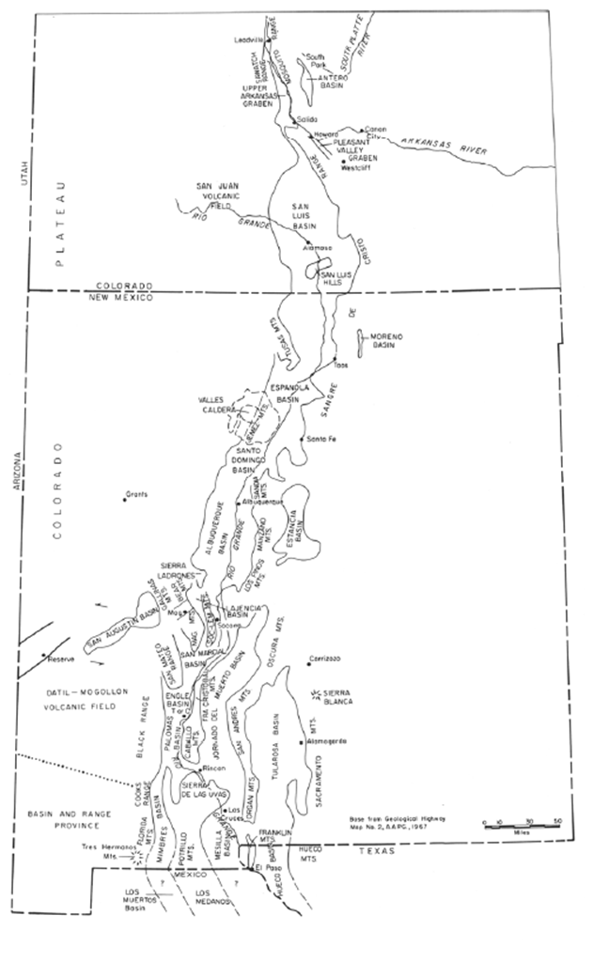
- Generalized map of the Rio Grande rift (after Chapin, 1971; from Chapin and Seager, 1975).
The following is the approach to complete this study component.
- Compile the digital boundaries of all subbasins in the URGB into a geodatabase. Some of the subbasins have well defined digital boundaries, but many do not. Subbasin boundaries will be acquired as digital data files from previous studies and (or) will be digitized in a vector format from figures in the literature.
- Compile existing cross sections from the literature. The literature will be examined for hydrostratigraphic picks for the tops and bases of units that include the sub-surface geology for subbasins where cross sections do not already exist. In those basins where enough data exist to construct a cross section, a cross section for that subbasin will be developed.
- Create a table of existing hydraulic property data for hydraulic conductivity and (or) transmissivity, and storage coefficients.

Water Levels
Existing water-level data from various sources will be used to develop water-level surface and water-level change maps for selected subbasins in the URGB. Water-level altitude data will be reviewed for duplicate measurements reported by multiple agencies, poor quality measurements, and measurements made at pumping wells. These data will be removed from the analysis. All point data will be converted to the same vertical datum and any depth to water measurements converted to a water-level altitude. Current (2016-2018 and (or) the year nearest to the target years that contain the most water-level measurements) and historical water-level data will be reviewed and an appropriate period will be selected to create current and historical water-level altitude maps and water-level change maps. The areas of water-level change will provide reasonable estimates of the general magnitude, extent, and spatial distribution of drawdown in the aquifer system, similar to the map by Powell and McKean (2014) for the Albuquerque Metropolitan area.
These data will be used to complete the following study components:
- Compile historical water-level data from multiple sources
    - USGS National Water Information System (NWIS)
    - Colorado Water Science Center - San Luis Basin
    - New Mexico Water Science Center - Santa Fe area and the Albuquerque, Rincon, and Mesilla Basins
    - Texas Water Science Center - Hueco Basin
    - Additional water levels are measured throughout New Mexico on a semi-annual, annual, or 5-year interval as part of the Groundwater Data Program in partnership with the NMOSE.
    - Water levels from other agencies in the Rincon and Mesilla Basins have been previously compiled as part of an ongoing USGS Rio Grande transboundary modeling project.
    - National Water-Quality Assessment (NAWQA) Program data from the Rio Grande Principal Aquifer Study
    - Federal, State, and local water resource agencies
- Analyze water-level status and trends and create change maps for selected subbasins
    - Create a set of wells with water-level measurements from both the current and historical period for use in the water-level trend and change analysis.
    - Conduct a statistical analysis similar to Burns and others (2012) on compiled water-level data to identify groups of wells with similar hydraulic heads and temporal trends in order to delineate areas of overall similar groundwater conditions.
- Develop water-level altitude maps for selected subbasins
    - Develop a preliminary surface using a GIS interpolator (for example topo to raster or kriging).
    - Manually adjust and reshape contours to conform to the data.
    - Complete a point-to-point subtraction on the set of wells to create water-level change values.
    - Develop a preliminary water-level change surface using a GIS interpolator (for example topo to raster or kriging).
    - Manually adjust and reshape contours to conform to the data.

Changes in Groundwater Storage
Changes in groundwater storage will be evaluated using water-level data and existing groundwater-flow models.
The following is the approach to complete this study component:
- Examine existing numerical flow models of the San Luis Valley (Colorado Water Conservation Board and Colorado Division of Water Resources), Espanola Basin (McAda and Wasiolek, 1988), Albuquerque Basin (Bexfield and others, 2011), the Mesilla and Rincon Basins (Hanson and others, 2013), and the Hueco Bolson (Heywood and Yager, 2003) and report simulated changes in groundwater storage. No updates will be done to any of the groundwater flow models, and no new simulations will be run.
- Estimate water in storage for selected subbasins from water-level surfaces and hydraulic properties.
- Review study results pertaining to aquifer compaction and subsidence in the San Luis Valley, Colorado (Reeves and others, 2014); the Albuquerque Basin (Heywood and others, 2002; on-going study with the Albuquerque Bernalillo County Water Utility Authority); and El Paso, Texas (Heywood, 2003) for a better understanding of loss of water in storage.

Surface Water
Recent studies have shown that the timing and availability of spring runoff is changing (Cayan and others, 2001; Stewart and others, 2004; Dettinger, 2005; Hidalgo and others, 2009; Clow, 2010; and Llewellyn and Vaddey, 2013), which probably will substantially affect the way surface water has to be managed in URGB. Because of the crucial role of the Rio Grande and its tributaries, it is important that water managers be able to plan for changes in the timing and availability of surface water and integrate knowledge of likely surface-water changes into a water-budget assessment. The URGB FAS will improve understanding of timing and availability of processes in the basin with three study components: snow processes, streamflow processes, and watershed processes.

Snow Processes (Study Component Lead: Graham Sexstone, Colorado Water Science Center)
Current water storage infrastructure (such as reservoirs) exists to capture and distribute snowmelt runoff to meet water supply and legal requirements of the Compact. However, because of changes in streamflow and precipitation, we can no longer assume that past patterns in streamflow can reliably be projected into the future (Milly and others, 2008). Processes that influence the variability of snow water equivalent (SWE) and sublimation, and thus the water yield from snowpack, are critical to measure in order to improve the ability of water managers to plan for changes in the timing and availability of snowmelt-derived water resources. Snowmelt processes in the snow-dominated headwaters of the URGB are influenced by energy-balance factors, such as sublimation and dust on snow. Water yield from winter snowpack may be altered through the complexity of reduced forests at high-elevation in the Rio Grande headwaters. Quantification of the role of snowmelt to the water budget of the Rio Grande requires better understanding of snowpack distribution and processes controlling its evolution (such as wind redistribution, sublimation, melt) in the headwaters of the Rio Grande.
There are 35 existing National Resources Conservation Service (NRCS) Snow Telemetry (SNOTEL) sites in the Upper Rio Grande Basin, of which 31 are located in the San Juan, Sangre de Cristo, and Jemez mountain ranges of northern New Mexico and southern Colorado (fig. 3). These sites are currently equipped with air temperature sensors, snow depth sensors, precipitation gages, and snow pillows to measure SWE; however, the addition of equipment to collect co-located energy and meteorological data will provide necessary enhancements to better measure and simulate snowpack water resources. Equipment installation will be analogous to current USGS project operations in Colorado, including the addition of sensors to measure wind speed and direction, soil moisture, solar radiation, snowpack temperature, snow surface temperature, and relative humidity sensors. Two SNOTEL sites will be retrofit with additional sensors to create ‘enhanced’ SNOTEL sites and one additional reduced-instrumentation site will be constructed within the targeted study HUC-8 subbasin: HUC ID #13010001, Rio Grande Headwaters (fig. 4). This HUC-8 subbasin was chosen because it is the most significantly snow-covered subbasin in the URGB, and the spatial distribution of existing SNOTEL sites provides good framework for instrumentation. Each SNOTEL sensor instrumentation ‘enhancement’ will cost approximately $10,000. Reclamation has pledged an additional $20,000 towards this effort, which is not shown in the budget table. Sensor enhancement has been successfully completed at SNOTEL sites in the Colorado River Basin to collect data for SnowModel efforts, and these same techniques and personnel will install instrumentation for these sites in the URGB.
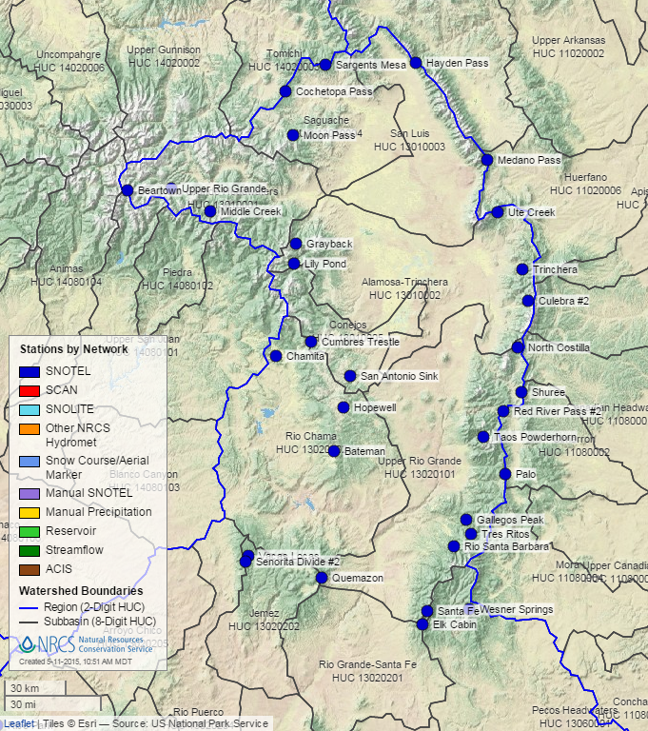
- Site map of existing SNOTEL sites in Region 13. Image from NRCS website (http://www.wcc.nrcs.usda.gov/webmap/index.html, accessed May 11, 2015.)
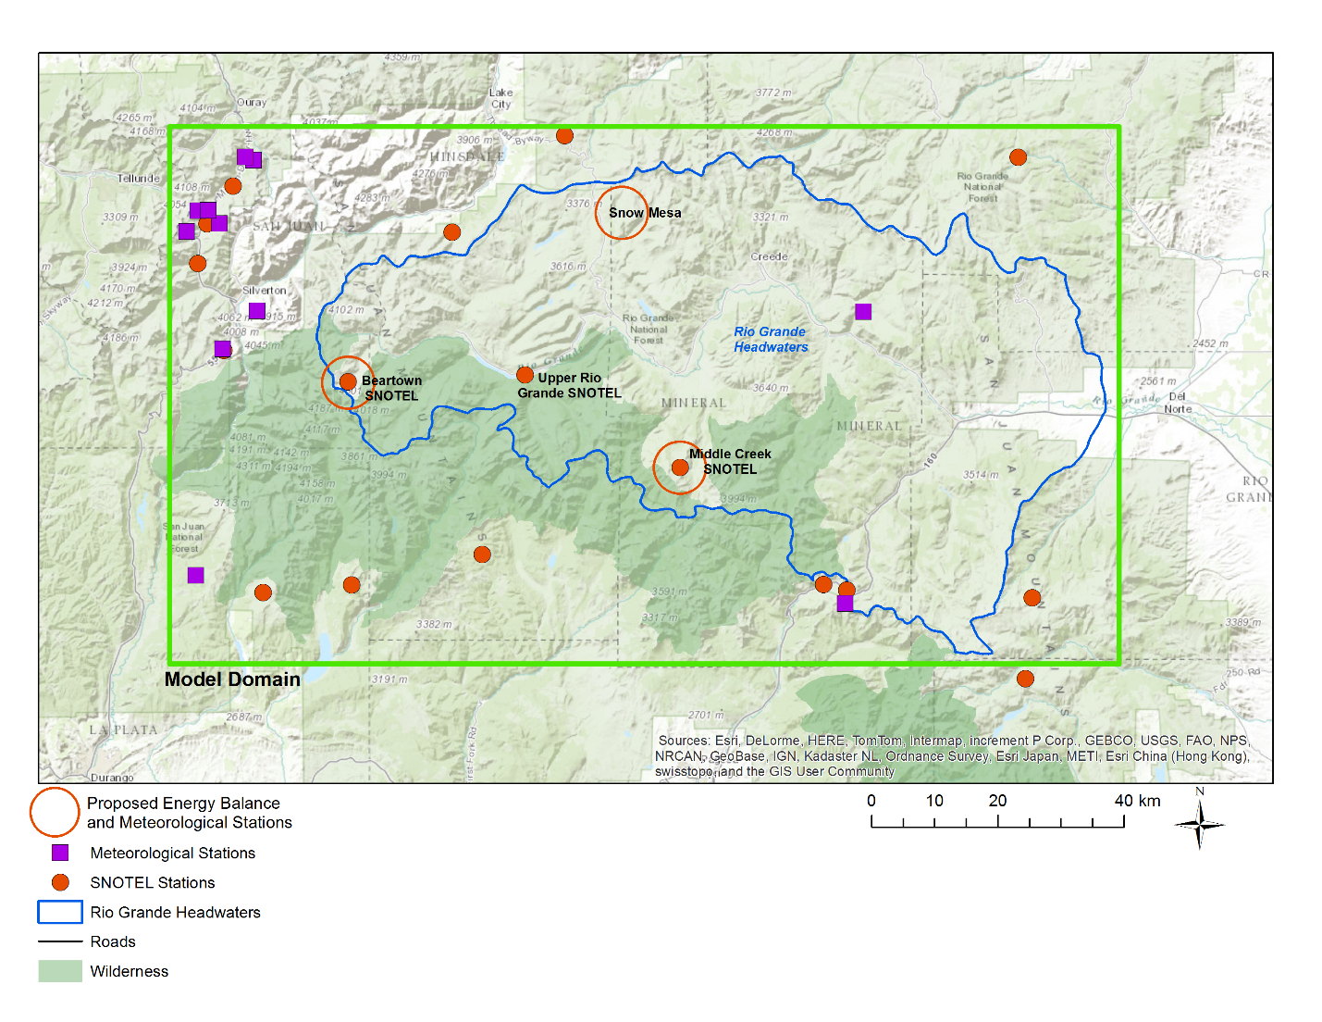
- Map of existing and proposed instrumentation within the Rio Grande Headwaters HUC-8 subbasin.
Dust on snow has been shown to decrease albedo, resulting in quicker snowmelt. Existing data collection by the Colorado Water Science Center (WSC) includes portions of the URGB, and shows that while dust on snow does influence snowmelt, there has been no trend over time. Two snowpack chemistry sites, which are part of the current dust on snow project, are located in New Mexico: Taos and Hopewell. Knowledge transfer from Colorado will continue; however, additional sampling will not be included as part of the URGB FAS due to the short study period and the unlikelihood of capturing any additional information with added data collection.
Processes affecting snowpack distribution and snowmelt will be modeled using a spatially distributed snowpack modeling system, SnowModel (Liston and Elder, 2006). Graham Sexstone and David Clow of the Colorado WSC will lead this effort. Models will be initially developed where additional instrumentation will be installed, the Rio Grande Headwaters HUC-8 subbasin. The models will be run at a fine spatial resolution (100 m) and the addition of the enhanced SNOTEL sites will improve the distribution of key input model forcing data. SnowModel will provide an improved representation of snowpack processes (for example, wind redistribution, sublimation, melt), which will help quantify this critical component of the overall URGB water balance. While only two snowmelt seasons (WY 2016 and WY 2017) during the study period will be included in the scope of this FAS, these data will provide critical baseline data for water managers to reassess predictions of water yield in snowmelt-dominated headwater watersheds. The addition of SnowModel in this URGB subbasin will extend the overall area of USGS SnowModel coverage for the intermountain west region.
The primary goal of this proposed task is to quantify and assess the snow water resources portion of the surface-water component of the URGB water budget for a selected subbasin. The specific objectives of this study will be to (1) add additional instrumentation to existing SNOTEL sites to enhance current snowpack data-collection efforts, (2) calibrate a snowpack evolution model using both new and existing instrumentation to develop gridded estimates of SWE, snow sublimation, and snowmelt runoff in one study subbasin, and (3) compare SnowModel results to current snow depletion curves used by forecasting agencies and PRMS.
The Rio Grande Headwaters study subbasin was chosen as the study area due to the deep snowpacks that are accumulated in this area, and relative spatial density of existing SNOTEL sites. Additionally, working in this subbasin allows for a collaborative effort with the Colorado Water Conservation Board (CWCB) and National Center for Atmospheric Research (NCAR), who are currently conducting snowmelt research in the Rio Grande Headwaters and Conejos subbasins. The spatial and temporal overlap of USGS and NCAR measurements and models could provide valuable information about snowmelt modeling approaches in the area as well as likely lead to additional collaborative work in the URGB headwaters. The following approach to complete this study component is outlined here.
- Purchase and install SNOTEL enhancement equipment.
  - Three SNOTEL sites (Beartown, Upper Rio Grande, and Middle Creek) will gain additional equipment (fig. 4)
  - One site (Snow Mesa) will be built with reduced equipment to provide greater spatial variability of data collection.
- Collect data from installed equipment during the study period (WY 2016 to WY 2017).
- Use collected data as input forcing data to run SnowModel for the Upper Rio Grande Headwaters subbasin during WY 2016 and WY 2017 in the defined model domain (fig. 4). Model results of interest will be summarized and provided as an archived dataset in ScienceBase.
- Compare spatially distributed snow water equivalent (SWE) from SnowModel with measured SWE at SNOTEL gages to determine how representative SNOTEL sites are of basin snow water resources. Also, compare modeled snowmelt from SnowModel with current snow depletion curves used by PRMS for watershed modeling in the URGB.

Streamflow Processes (Study Component Lead: Matt Miller, Utah Water Science Center)
Streamflow processes in the URGB will be investigated by 1) estimating the relative contributions of runoff (surface water) and baseflow (groundwater discharge) in streamflow, and 2) evaluating trends in total streamflow and baseflow over time. Recent studies have shown that the timing and availability of spring runoff is changing (Cayan and others, 2001; Stewart and others, 2004; Dettinger, 2005; Hidalgo and others, 2009; Clow, 2010; and Llewellyn and Vaddey, 2013), which may substantially affect the way surface water has to be managed in the URGB. Recent studies also highlight the importance of baseflow, or groundwater discharge to streams, in sustaining surface water flows. For example, in the Upper Colorado River Basin, baseflow contributes approximately 50% of the total streamflow, and is generated in high elevation watersheds where snow and increased precipitation occur (Miller and others, 2016). Because of the crucial role of the Rio Grande and its tributaries, it is important that water managers be able to plan for changes in the timing and availability of surface water, and that they understand the baseflow contribution to total streamflow, so that they are able to integrate knowledge of surface-water sources and changes into a water-budget assessment.
Graphical and hydrochemical (specific conductance) hydrograph separation techniques will be explored at selected sites throughout the URGB to quantify baseflow discharge to streams. Prior to employing the hydrochemical technique, an inventory of streamflow records within NWIS will be conducted to determine streamgage locations where both discharge and specific conductivity data have been collected over the same time period in the URGB. Streamgages determined to have sufficient data density to assess variability will be chosen for further hydrograph separation techniques using automated streamflow-hydrograph methods (i.e. the USGS Groundwater Toolbox) and the recursive digital filter method (Barlow and others, 2015; Eckhardt, 2005).
Automated streamflow-hydrograph methods in the Groundwater Toolbox, such as HYSEP (Sloto and Crouse, 1996) or PART (Rutledge, 1998), will be applied to estimate the baseflow component of streamflow. Both methods estimate the contribution from groundwater to streamflow by using daily streamflow response to an event; PART uses the rate and shape of streamflow recession curves, while HYSEP uses an algorithm to create a linear interpolation between low points on the hydrograph, thus separating event flow from baseflow (Barlow and others, 2015). In addition, baseflow will be estimated using the recursive digital filter method, which uses low-pass filtering to identify low frequency variability in streamflow that is associated with baseflow (Eckhardt, 2005). Results will be analyzed to quantify the amount, spatial distribution, and variability of groundwater contribution to streamflow in the Rio Grande. Automated hydrograph separation techniques have limitations; they assume no loss of groundwater to the underlying aquifer (“losing behavior”), and are not recommended for drainage areas less than one square mile or greater than 500 square miles. Additionally, automated hydrograph separation may not be appropriate for reaches directly downstream of reservoirs, as the methods cannot differentiate between a storm event and a reservoir release (Barlow and others, 2015). The recursive digital filter method is limited to watersheds where it is appropriate to assume a linear relation between aquifer storage and its outflow (Eckhardt, 2005). Inventory of existing data and preliminary analysis will be necessary to determine where these methods can be applied in the URGB.
The contribution of groundwater to streams and rivers can also be quantified using hydrochemical data and a mass-balance approach (House and Warwick, 1998; Velbel, 1985). Groundwater contribution to surface water within select/specific areas of the URGB has been quantified previously using a variety of hydrochemical separation techniques (Anderholm and Heywood, 2003; Bexfield and Anderholm, 2008; Liu and others, 2008; Moore and others, 2004). The methods used in these studies are generally limited by the frequency, locations, and breadth of hydrochemical data collection. The development and use of a technique using discrete specific conductance (SC) to quantify groundwater contribution to surface water in the URGB would expand the temporal and spatial resolution understanding of these groundwater/surface water connections. Investigations in the Colorado River Basin have developed a two-component separation technique using SC to separate baseflow and streamflow for selected snowmelt-dominated subbasins (Miller and others, 2014; 2015; 2016; Rumsey and others, 2015). The feasibility of this technique to subbasins in the URGB and application to those areas will be explored as the effect of reservoir storage and release on SC in the URGB will not be consistent with snowmelt-dominated flow.
The primary goal of this study component is to quantify and assess the spatial and temporal variability of streamflow and baseflow in the URGB using available data. Because changes in streamflow could substantially affect the way surface water must be managed in the URGB, it is important that water managers have a readily available and up-to-date assessment of surface-water resources. The following approach to complete this study component is outlined here.
- Estimate baseflow with graphical hydrograph separation.
  - Determine availability of existing data within USGS databases to perform graphical hydrograph separation techniques. Data inventory results will determine the spatial and temporal extent of these analyses.
  - Evaluate graphical hydrograph separation using a variety of techniques and the maximum number of streamgages and temporal bounds as data allow.
    - Apply methods within the USGS Groundwater Toolbox to estimate the baseflow component of streamflow.
    - Estimate baseflow using the recursive digital filter technique.
  - Compare graphical hydrograph separation results from different techniques where there exists a spatiotemporal overlap of analysis.
- Estimate baseflow with hydrochemical hydrograph separation.
  - Determine availability of existing data within USGS databases. Data inventory results will determine the spatial and temporal extent of these analyses.
  - Apply criteria to discharge and water quality data to ensure that hydrochemical baseflow separation is appropriate for each site.
  - Where available, use specific conductance data to calculate contribution from baseflow to surface water over time.
  - Compare hydrochemical hydrograph separation baseflow estimates to graphical hydrograph separation results.
    - Evaluate whether there is a graphical hydrograph separation approach that most consistently matches results of the hydrograph separation approach.
- Explore drivers in spatial variability of baseflow discharge
  - Statistically relate baseflow estimates to watershed characteristics such as climate, soil, topography, and land cover variables.
- Timing and trends analysis
  - Obtain daily mean streamflow data from the network of USGS streamflow gaging stations within the URGB (fig. 5).
  - Evaluate streamflow trends, timing, and estimated streamflow on the subbasin scale, considering the effects of reservoir releases and gains and losses of conveyance structures.
  - Analyze historical streamflow records from selected sites on the Rio Grande and selected tributaries for trends in seasonal and annual streamflow including start of spring runoff, peak flow, and the low flow (baseflow) time period.
  - Compare timing and trends analyses for total streamflow and the baseflow component of flow.
  - Consider the influence of anthropogenic effects, such as reservoir releases and conveyance structures, on streamflow and baseflow over time.
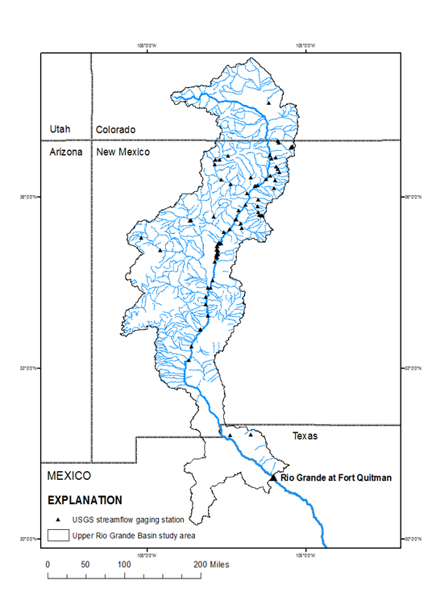
- Locations of U.S. Geological Survey streamflow gaging stations in the Upper Rio Grande Focus Area Study, Colorado, New Mexico, and Texas.

Watershed Modeling (Study Component Lead: Kyle Douglas-Mankin, New Mexico Water Science Center)
The Precipitation-Runoff Modeling System (PRMS) is a component of the National Hydrologic Model (NHM), developed by the USGS (Markstrom and others, 2015). PRMS is a deterministic, processed-based, distributed-parameter modeling system designed to analyze the effects of precipitation, climate, and land use on streamflow and general basin hydrology on a daily timescale. The national-scale framework of the NHM allows for sub-catchment modelling using the model-defined spatially-distributed Hydrologic Response Units (HRUs). The model input data also include precipitation, minimum temperature, maximum temperature, solar radiation, and potential evapotranspiration.
USGS New Mexico Water Science Center, in conjunction with the USGS Office of Surface Water and the National Research Program Modeling of Watershed Systems working group, are developing and calibrating PRMS for the Upper Rio Grande Basin. The evapotranspiration, snow processes, streamflow processes and water use components of this study will be used to inform parameterization and calibration of the model.
The goal of the modeling effort will be to (a) integrate new data and understanding of water-balance components developed from other FAS tasks into the PRMS modeling framework, (b) parameterize and calibrate PRMS to better represent local and regional hydrologic conditions, and (c) use PRMS simulations and scenarios to inform understanding of trends and spatial variability of critical water-budget elements at the HRU scale across the URGB.

Data and Study Results Visualization (Study Component Lead: Daniel Pearson, Texas Water Science Center)
The URGB FAS will produce a wide array of science products about water use and availability in each subbasin, setting the stage for managing water resources more efficiently and with better understanding of current and future conditions. Building on existing mapping concepts, this study component will focus on development of an interactive website that will provide a single visual and quantitative summary of available water resources information produced and compiled for the URGB FAS. The interactive website will include a web mapping application and a project website that will serve as the “Common Operating Data Frame” for the URGB FAS. Where available and appropriate, hydrologic data/information will be displayed using 3-D graphics, which will be shown proportionally based on total capacity.
The creation of a new, public-facing website and mapping application could be extremely valuable to the community of professionals managing and monitoring water resources in the URGB. This new web presence intends to provide access to water data available for the URGB and access to research products stemming from the URGB FAS. In addition, data connections to current conditions such as drought information and water use/consumption will be considered in the future to communicate this information to various stakeholders in the basin. The approach to complete this study component is outlined here.
- Develop and host a web application using a stable development/production server environment, building on existing code libraries already in place at the USGS Texas WSC.
- Create a project website, including connection to the web mapping application and providing background information about the URGB FAS. In addition, a Help Page will be developed to accompany the interactive website, which describes how-to use the application and describes data contents. NWIS Web Data Access will be made more user-friendly with HTML links provided to the NWIS sites in list form for easy access by users.
- Use an infographic-styled mapping application, including custom cartographic data layers, USGS Water Watch symbology for all USGS streamgages, connection to USGS NWIS web services (and possibly Reclamation) for real-time information, data pop-ups with all water information presented in an organized/structured simple manner.
The URGB FAS web presence will not provide data download capabilities. Given existing functions on the National Water Census Data Portal, the intent of the URGB FAS web mapping application and interactive website will be to build on those aspects of the Data Portal by providing visualization of real-time data conditions and high-level study-specific results along with providing an interactive story map presentation of the URGB FAS. The developing group from the USGS Texas Water Science Center will maintain the web presence for the duration of the study. They will coordinate their activities with personnel from the USGS Center for Integrated Data Analytics to ensure compatibility and eliminate duplication of efforts. At the conclusion of the FAS, New Mexico Water Science Center will continue to fund and support the website and mapping application.

Data Management and Planning (Study Component Lead: Diana Pedraza, Texas Water Science Center)
A component of the National Water Census is a collection of computing infrastructure referred to as the data platform. The platform and a web portal built using its services enable integration and delivery of water-budget information alongside other data, such as water-use data and ecological assessment criteria (Blodgett, 2015). Data management plans will be created to document handling of project inputs and outputs, important software and models, and the intention for archiving study results and products. Data will be managed, archived, and made available using architecture described in figure 6. Tom Burley and Diana Pedraza of the Texas WSC will provide technical oversight of the data management component.

- Schematic of data management architecture (modified from Blodgett, 2015).

Products and Deliverables
The URGB FAS will produce an array of science products oriented toward the public, key stakeholders, and the scientific community. The heart of information delivery will be an interactive website with a web-mapping application that will deliver water resources information and geospatial data developed by the FAS for the URGB. The project website will be updated throughout the study to disseminate datasets, project status, stakeholder information, and publications. Scientific products will be produced for most project components. USGS Data Series Report(s) of compiled hydrologic data will be published at the completion of the study (September 2018). A USGS Scientific Investigations Report will present a comprehensive synthesis of water-use data and other spatially distributed water resource data and reflect the knowledge gained about factors that contribute to shortages of available water in the URGB. The scope and extent of specific products will be dictated by the final project results. Expected products include the following:
Water Use Deliverables:
- USGS Scientific Investigations Report summarizing water use, water use trends and consumptive use for the URGB.
Evapotranspiration Deliverables:
- Journal article describing methods used to develop and verify monthly and seasonal ET grids at the Landsat scale using the SSEBop ET model and an analysis of results for the URGB.
Groundwater Deliverables:
- USGS Scientific Investigations Map of estimated water-level surfaces and water-level change maps for selected sub-basins in the URGB.
- Data release of a file-based geodatabase of geospatial data.
Snow Processes Deliverables:
- SnowModel results of interest from WY 2016 and WY 2017 summarized and provided in ScienceBase as an archived dataset.
- Journal article highlighting modeled snow variability and representivity of SNOTEL gages in the UCRB. Paper will include SnowModel evaluation by field surveys and NASA ASO and snow processes sensitivity to forest change.
- Journal article on establishing linkage between SnowModel output and PRMS representation of snowmelt in the headwaters basin.
Streamflow Processes Deliverables:
- Time series estimates of baseflow discharge to streams obtained from multiple approaches at select sites in the URGB.
- Journal article describing the temporal and spatial variability in baseflow discharge to streams in the URGB.
Watershed Processes Deliverables:
- USGS Scientific Investigations Report documenting URGB PRMS model development and calibration. PRMS model and datasets will be provided in ScienceBase as an archived model and dataset.
- Journal article describing simulated temporal and spatial variability in water-balance components in the URGB and implications for Basin water management.

Timelines
All work will be completed within the three-year study period. Specific tasks will be scheduled around hydrologic conditions, required completion of other study tasks and concurrent USGS studies, and annual funding availability. A project website will be maintained throughout the length of the project. A detailed timeline for the study is provided in the table below.

Budget
Total cost of the Upper Rio Grande Basin Focus Area Study will be $1.5 million over three fiscal years (FYs). The budget covers all salary and other expenses to support the objectives and approach detailed above. Study components can be expanded to investigate important water-budget characteristics if additional funds from other cooperators and partners become available. No expansion of the study scope will alter the final timelines. Specific tasks are receiving additional resources separate from the URGB FAS funds. Reclamation has agreed to provide at least $20,000 for the SNOTEL site instrumentation enhancements. ET Topical Study funds will be used to supplement URGB FAS funds for the SSEBop modeling and generation of ET maps.

References
Affinati, J.A., and Myers, N.C., 2015, Assessment of statewide annual streamflow in New Mexico, 1985–2013: U.S. Geological Survey Scientific Investigations Report 2015–5082, 65 p., http://dx.doi.org/10.3133/sir20155082.
Anderholm, S.K., and Heywood, C.E., 2003, Chemistry and age of ground water in the southwestern Hueco Bolson, New Mexico and Texas: U. S. Geological Survey Water-Resources Investigations Report 02-4237, 16 p.
Barlow, P.M., Cunningham, W.L., Zhai, T., and Gray, M., 2015, U.S. Geological Survey Groundwater Toolbox, A Graphical and Mapping Interface for Analysis of Hydrologic Data (Version 1.0)—User Guide for Estimation of Base Flow, Runoff, and Groundwater Recharge From Streamflow Data: U.S. Geological Survey Techniques and Methods 3-B10, 27 p.
Barlow, P.M., and Leake, S.A., 2012, Streamflow depletion by wells—Understanding and managing the effects of groundwater pumping on streamflow: U.S. Geological Survey Circular 1376, 84 p.
Bartolino, J.R., and Cole, J.C., 2002, Ground-water resources of the Middle Rio Grande Basin, U. S. Geological Survey Circular 1222, 132 p.
Bexfield, L.M., and Anderholm, S.K., 2008, Potential chemical effects of changes in the source of water supply for the Albuquerque Bernalillo County Water Utility Authority: U.S. Geological Survey Scientific Investigations Report 2006−5171, 48 p.
Bexfield, L.M., Heywood, C.E., Kauffman, L.J., Rattray, G.W., and Vogler, E.T., 2011, Hydrogeologic setting and groundwater-flow simulation of the Middle Rio Grande Basin regional study area, New Mexico, section 2 of Eberts, S.M., ed., Hydrologic settings and groundwater flow simulations for regional investigations of the transport of anthropogenic and natural contaminants to public-supply wells—Investigations begun in 2004: Reston, Va., U.S. Geological Survey Professional Paper 1737–B, p. 2-1–2-61.
Brown and Caldwell Consulting Engineers, 1984, Residential water conservation projects — summary report: U.S. Department of Housing and Urban Development, Office of Policy and Development and Research, Washington, D.C.
Burns, E.R, Snyder, D.T, Haynes, J.V., and Waibel, M.S., 2012, Groundwater status and trends for the Columbia Plateau Regional Aquifer System, Washington, Oregon, and Idaho: U.S. Geological Survey Scientific Investigations Report 2012–5261, 52 p., http://pubs.er.usgs.gov/publication/sir20125261.
Cayan, D.R., Dettinger, M.D., Kammerdiener, S.A., Caprio, J.M., and Peterson, D.H., 2001, Changes in the Onset of Spring in the Western United States: Bulletin of the American Meteorological Society, v. 82, no. 3, p. 399–415.
Chapin, C.E., 1971, The Rio Grande rift, Part I: Modifications and additions: Socorro, New Mexico Geological Society Guidebook 22 p. 191-201.
Chapin, C.E., 1979, Evolution of the Rio Grande rift - A summary, in Rieker, R.E., ed., Rio Grande rift--Tectonics and Magmatism: American Geophysical Union, Washington, D.C., 438 p.
Chapin, C.E., and Seager, W.R., 1975, Evolution of the Rio Grande rift in the Socorro and Las Cruces areas, in Las Cruces Country, Seager, W. R.; Clemons, R. E.; Callender, J. F.; [eds.], New Mexico Geological Society 26th Annual Fall Field Conference Guidebook, 376 p.
Clow, D.W., 2010, Changes in timing of snowmelt and streamflow in Colorado: a response to recent warming: Journal of Climate, v. 23, p. 2293-2306.
Crilley, D.M., Matherne, A.M., Thomas, Nicole, and Falk, S.E., 2013, Seepage investigations of the Rio Grande from below Leasburg Dam, Leasburg, New Mexico, to above American Dam, El Paso, Texas, 2006–13: U.S. Geological Survey Open-File Report 2013–1233, 34 p.
Dettinger, M.D., 2005, Changes in streamflow timing in the western United States in recent decades: U.S. Geological Survey Fact Sheet 2005-3018, 4p.
Falk, S.E., Anderholm, S.K., and Hafich, K.A., 2013, Water quality, streamflow conditions, and annual flow-duration curves for streams of the San Juan–Chama Project, southern Colorado and northern New Mexico, 1935–2010: U.S. Geological Survey Scientific Investigations Report 2013–5005, 50 p., 1 app.
Hanson, R.T., Schmid, Wolfgang, Knight, Jake, and Maddock III, T., 2013, Integrated hydrologic modeling of a transboundary aquifer system — Lower Rio Grande: MODFLOW and More 2013: Translating Science into Practice, Golden, CO, June 2-6, 2013.
Heywood, Charles E., 2003. Summary of extensometric measurements in El Paso, Texas. Water-Resources Investigations Report 2003-4158, 11 p.
Heywood, C.E., Galloway, D.L., and Stork, S.V., 2002, Ground displacements caused by aquifer-system water-level variations observed using interferometric synthetic aperture radar near Albuquerque, New Mexico. Water-Resources Investigations Report 2002-4235, 18 p.
Heywood, C.E., and Yager, R.M., 2003, Simulated ground-water flow in the Hueco Bolson, an alluvial-basin aquifer system near El Paso, Texas: U.S. Geological Survey Water-Resources Investigations Report 02-4108, 73 p.
Hidalgo, H.G., Das, T., Dettinger, M.D., Cayan, D.R., Pierce, D.W., Barnett, T.P., Bala, G., Mirin, Aq., Wood, A.W., Bonfils, C., Santer, B.D., And Nozawa, T., 2009, Detection and Attribution of Streamflow Timing Changes to Climate Change in the Western United States: Journal of Climate, volume 22, p. 3838-3855.
Horn, M.A., Moore, R.B., Hayes, Laura, and Flanagan, S.M., 2008, Methods for and estimates of 2003 and projected water use in the Seacoast region, southeastern New Hampshire: U.S. Geological Survey Scientific Investigations Report 2007-5157, 87 p., plus 2 appendixes on CD ROM.
Hornberger, G.M., Hess, D.J., and Gilligan, Jonathan, 2015, Water conservation and hydrological transitions in cities in the United States; Water Resources Research, v. 51, p 4635-4649.
House, W.A., and Warwick, M.S., 1998, A mass-balance approach to quantifying the importance of in-stream processes during nutrient transport in a large river catchment: Science of The Total Environment, v. 210–211, p. 139–152.
Keller, G.R., and Cather, S.M., 1994, Introduction: in Keller, G.R., and Cather, S.M., eds., Basins of the Rio Grande rift: structure, stratigraphy, and tectonic setting: Geological Society of America Special Paper 291 p. 1-4.
Langman, J.B., and Anderholm, S.K, 2004, Effects of reservoir installation, San Juan–Chama Project water, and reservoir operations on streamflow and water quality in the Rio Chama and Rio Grande, northern and central New Mexico, 1938–2000: U.S. Geological Survey Scientific Investigations Report 2004–5188, 47 p.
Leake, S.A., Reeves, H.W., and Dickinson, J.E., 2010, A new capture fraction method to map how pumpage affects surface water flow: Ground Water, v. 48, no. 5, p. 690–700.
Lins, Harry, 2005, Streamflow trends in the United States: U.S. Geological Survey Fact Sheet 2005–3017, 4 p., accessed March 15, 2015, at http://pubs.er.usgs.gov/publication/fs20053017.
Liston, G.E., and Elder, K., 2006, A Distributed Snow-Evolution Modeling System (SnowModel): Journal of Hydrometeorology, v. 7, no. 6, p. 1259–1276.
Liu, F., Parmenter, R., Brooks, P.D., Conklin, M.H., and Bales, R.C., 2008, Seasonal and interannual variation of streamflow pathways and biogeochemical implications in semi-arid, forested catchments in Valles Caldera, New Mexico: Ecohydrology, v. 1, no. 3, p. 239–252.
Llewellyn, D., and Vaddey, S., 2013, West-wide climate risk assessment: Upper Rio Grande impact assessment, U.S. Bureau Reclamation, Upper Colorado Region, Albuquerque, NM, 138 p.
Longworth, J.W., Valdez, J.M., Magnuson, M.L., and Richard, Kenneth, 2013, New Mexico Water Use by Categories 2010: New Mexico State Engineer Office, Technical Report 54, 128 p.
Markstrom, S.L., Regan, R.S., Hay, L.E., Viger, R.J., Webb, R.M.T., Payn, R.A., and LaFontaine, J.H., 2015, PRMS-IV, the precipitation-runoff modeling system, version 4: U.S. Geological Survey Techniques and Methods, book 6, chap. B7, 158 p., http://dx.doi.org/10.3133/tm6B7.
McAda, D. P. and Wasiolek, Maryann, 1988, Simulation of the regional geohydrology of the Tesuque aquifer system near Santa Fe, New Mexico: U.S. Geological Survey Water-Resources Investigations Report 87-4056, 71 p.
Miller, M.P., Susong, D.D., Shope, C.L., Heilweil, V.M. and Stolp, B.J., 2014, Continuous estimation of baseflow in snowmelt-dominated streams and rivers in the Upper Colorado River Basin: A chemical hydrograph separation approach. Water Resources Research, 50, 6986-6999, doi:10.1002/2013WR014939.
Miller, M.P., Johnson, H.M., Susong, D.D., and Wolock, D.M., 2015, A new approach for continuous estimation of baseflow using discrete water quality data: Method description and comparison with baseflow estimates from two existing approaches. Journal of Hydrology, 522, 203-210, doi:10.1016/j.hydrol.2014.12.039.
Milly, P.C.D., Betancourt, Julio, Falkenmark, Malin, Hirsch, R.M., Kundzewicz, Z.W., Lettenmaier, D.P., and Stouffer, R.J., 2008, Stationarity Is Dead: Whither Water Management?: Science, v. 319, p. 573-574.
Moore, S.J., and Anderholm, S.K., Moore, 2002, Spatial and temporal variations in streamflow, dissolved solids, nutrients, and suspended sediment in the Rio Grande Valley Study Unit, Colorado, New Mexico, and Texas, 1993-95: 2002, U.S. Geological Survey Water-Resources Investigations Report 02-4224, 52 p.
Moore, S.J., Anderholm, S.K., Williams-Sether, T., and Stomp, J.M., 2004, Sources of water to the Rio Grande upstream from San Marcial, New Mexico: U.S. Geological Survey Fact Sheet 110-03.
Moore, S. J., Bassett, R. L., Liu, B., Wolf, C. P., and Doremus, D., 2008, Geochemical tracers to evaluate hydrogeologic controls on river salinization: Groundwater, v. 46, p. 489–501.
Moyer, D.L., Anderholm, S.K., Hogan, J.F., Phillips, F.M., Hibbs, B.J., Witcher, J.C., Matherne, A.M., and Falk, S.E., 2013, Knowledge and understanding of dissolved solids in the Rio Grande–San Acacia, New Mexico, to Fort Quitman, Texas, and plan for future studies and monitoring: U.S. Geological Survey Open-File Report 2013–1190, 55 p., http://pubs.usgs.gov/of/2013/1190/.
Powell, R.I., and McKean, S.E., 2014, Estimated 2012 groundwater potentiometric surface and drawdown from predevelopment to 2012 in the Santa Fe Group aquifer system in the Albuquerque metropolitan area, central New Mexico: U.S. Geological Survey Scientific Investigations Map 3301, 1 sheet.
Reeves, J.A., Knight, Rosemary, Zebker, H.A, Kitanidis, P.K., and Scheruder, W.A., 2014, Estimating temporal changes in hydraulic head using InSAR data in the San Luis Valley, Colorado: Water Resour. Res., v. 50, no. 5, p. 4459–4473.
Risser, D.W., Conger, R.W., Ulrich, J.E., and Asmussen, M.P., 2005, Estimates of Ground-Water Recharge Based on Streamflow-Hydrograph Methods: Pennsylvania: U.S. Geological Survey Open-File Report 2005-1333, 30 p.
Rutledge, A.T., 1998, Computer programs for describing the recession of ground-water discharge and for estimating mean ground-water recharge and discharge from streamflow records—update: U.S. Geological Survey Water-Resources Investigations Report 98-4148, 43 p.
Senay, G.B, Bohms, S., Singh, R., Gowda, P., Velpuri, N.M., Alemu, H., and Verdin, J., 2013, Operational evapotranspiration modeling using remote sensing and weather datasets: A new parameterization for the SSEB ET approach: Journal of the American Water Resources Association, v. 49, issue 3, p. 577-591.
Shaffer, K.H., 2009, Variations in withdrawal, return flow, and consumptive use of water in Ohio and Indiana, with selected data from Wisconsin, 1999–2004: U.S. Geological Survey Scientific Investigations Report 2009–5096, 93 p.
Sloto, R.A., and Crouse, M.Y., 1996, HYSEP: A computer program for streamflow hydrograph separation and analysis, U.S. Geological Survey Water Resources Investigation Report 96-4040, 46 p.
S.S. Papadopulos & Associates, 2002, Assessment of flow conditions and seepage on the Rio Grande and adjacent channels, Isleta to San Marcial, Summer 2001: Prepared for New Mexico Interstate Stream Commission, variously paginated.
Stewart, I.T., Cayan, D.R., and Dettinger, M.D., 2004, Changes toward Earlier Streamflow Timing across Western North America: Journal of Climate, v. 18, p. 1136-1155.
Veenhuis, J.E., 2002, Summary of flow loss between selected cross sections on the Rio Grande in and near Albuquerque, New Mexico: U.S. Geological Survey Water-Resources Investigations Report 02-4131, 30 p.
Velbel, M.A., 1985, Geochemical mass balances and weathering rates in forested watersheds of the southern Blue Ridge: American Journal of Science, v. 285, no. 10, p. 904–930.
Winter, T.C., Harvey, J.W., Franke, O.L., and Alley, W.M., 1998, Ground water and surface water: a single resource: U.S. Geological Survey Circular 1139, 80 p.

